For Sale – Reconditioned Vestas V17
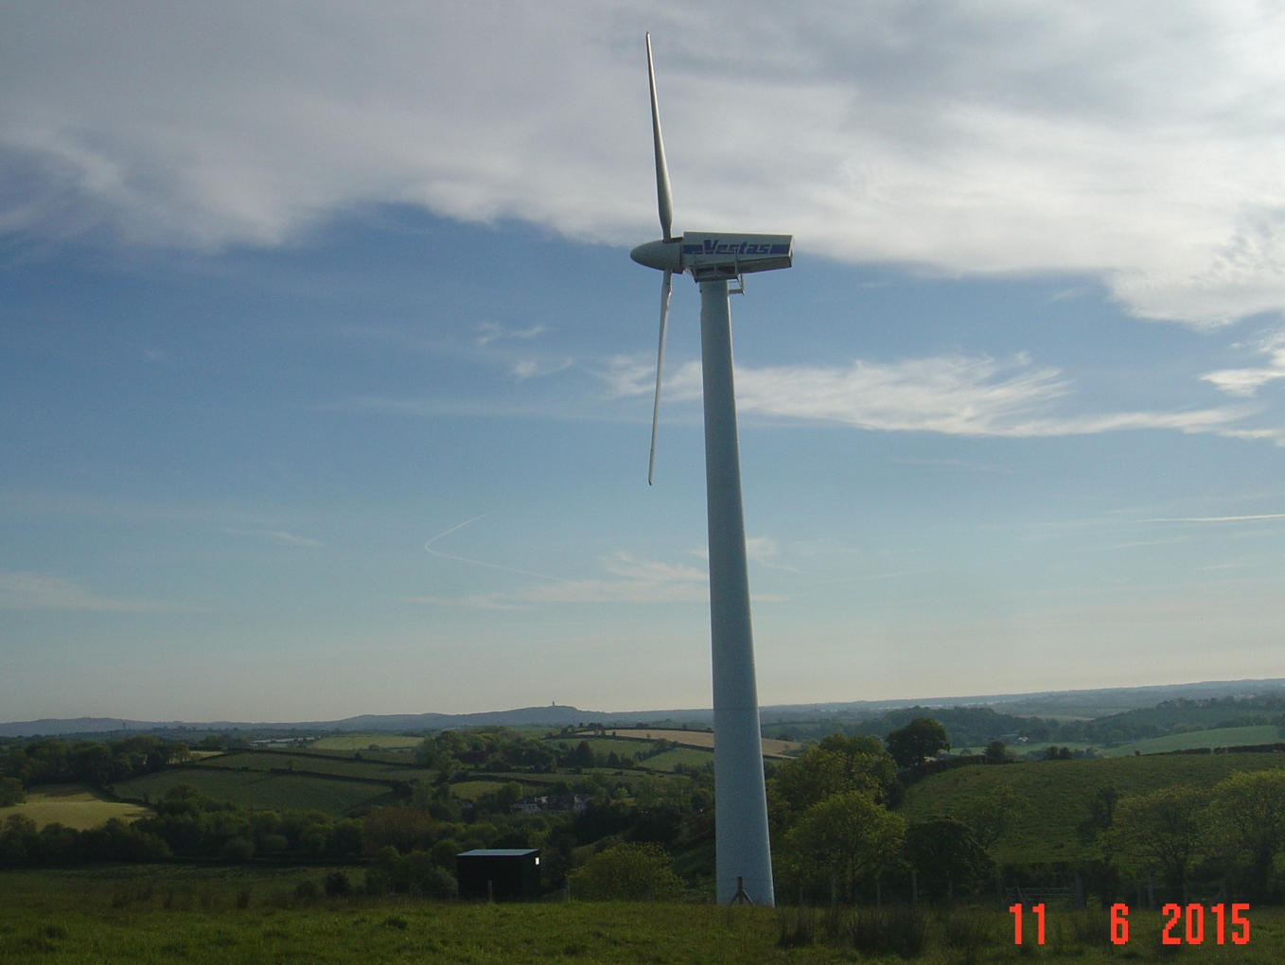

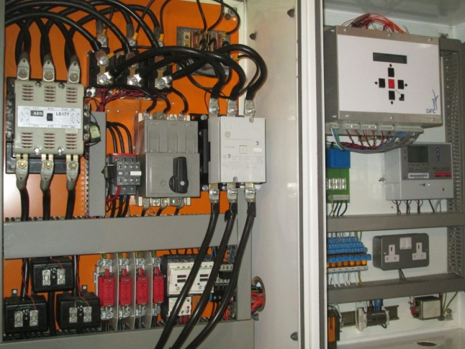 | 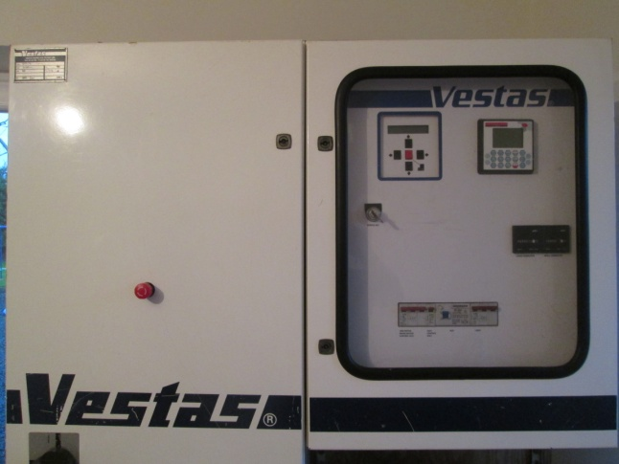
Specification  - Fully refurbished Vestas V17.  - New controller (Orbital) giving remote monitoring capability.  - Gearbox overhauled.  - Generator rewound.  - New brake calipers.  - Complete repaint.  - Reconditioned yaw motor.  - New yaw pads.  - 23 m tower. | Service History  - Installed January 2013  - Service contract with turbine installer. Serviced at 6 monthly intervals.  - Anemometer replaced – Jan 2014.  - Average 145,000 kWh generated per year (7.5 m/s site).  - All cables, nuts and bolts will be retained  - Excellent condition

